**Bugs:**

* **The term used when programs through errors that we didn’t expect to encounter**
* **Will be denoted with a ^ symbol and a location to the line where the issue is**
* **A good troubleshooting tip is to start inserting *print()* statements to see what the code produces up to that point  
    
  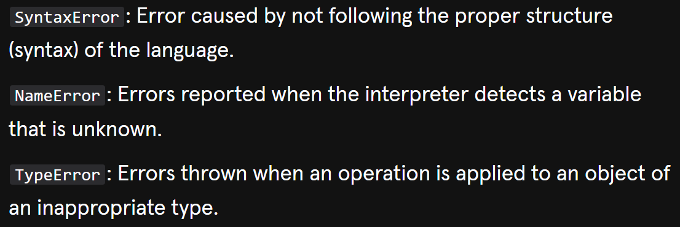**
* **A black screen with red text

  Description automatically generatedA black background with red text

  Description automatically generated**
* **A black background with red text

  Description automatically generated**